Data and analytics capabilities have made a leap forward in recent years. The volume of available data has grown exponentially, more sophisticated algorithms have been developed, and computational power and storage have steadily improved. The convergence of these trends is fueling rapid technology advances and business disruptions.  Most companies are capturing only a fraction of the potential value from data and analytics. Our 2011 report estimated this potential in five domains; revisiting them today shows a great deal of value still on the table. The greatest progress has occurred in location-based services and in retail, both areas with digital native competitors. In contrast, manufacturing, the public sector, and health care have captured less than 30 percent of the potential value we highlighted five years ago. Further, new opportunities have arisen since 2011, making the gap between the leaders and laggards even bigger.  The biggest barriers companies face in extracting value from data and analytics are organizational; many struggle to incorporate data-driven insights into day-to-day business processes. Another challenge is attracting and retaining the right talent—not only data scientists but business translators who combine data savvy with industry and functional expertise.  Data and analytics are changing the basis of competition. Leading companies are using their capabilities not only to improve their core operations but to launch entirely new business models. The network effects of digital platforms are creating a winner-take-most dynamic in some markets.  Data is now a critical corporate asset. It comes from the web, billions of phones, sensors, payment systems, cameras, and a huge array of other sources—and its value is tied to its ultimate use. While data itself will become increasingly commoditized, value is likely to accrue to the owners of scarce data, to players that aggregate data in unique ways, and especially to providers of valuable analytics.  Data and analytics underpin several disruptive models. Introducing new types of data sets (“orthogonal data”) can disrupt industries, and massive data integration capabilities can break through organizational and technological silos, enabling new insights and models. Hyperscale digital platforms can match buyers and sellers in real time, transforming inefficient markets. Granular data can be used to personalize products and services—and, most intriguingly, health care. New analytical techniques can fuel discovery and innovation. Above all, data and analytics can enable faster and more evidencebased decision making.  Recent advances in machine learning can be used to solve a tremendous variety of problems—and deep learning is pushing the boundaries even further. Systems enabled by machine learning can provide customer service, manage logistics, analyze medical records, or even write news stories. The value potential is everywhere, even in industries that have been slow to digitize. These technologies could generate productivity gains and an improved quality of life—along with job losses and other disruptions. Previous MGI research found that 45 percent of work activities could potentially be automated by currently demonstrated technologies; machine learning can be an enabling technology for the automation of 80 percent of those activities. Breakthroughs in natural language processing could expand that impact even further. Data and analytics are already shaking up multiple industries, and the effects will only become more pronounced as adoption reaches critical mass. An even bigger wave of change is looming on the horizon as deep learning reaches maturity, giving machines unprecedented capabilities to think, problem-solve, and understand language. Organizations that are able to harness these capabilities effectively will be able to create significant value and differentiate themselves, while others will find themselves increasingly at a disadvantage

THE FRONTIERS OF MACHINE LEARNING, INCLUDING DEEP LEARNING,

HAVE RELEVANCE IN EVERY INDUSTRY AND WIDE-RANGING POTENTIAL TO

SOLVE PROBLEMS

Machine learning can enhance the power of each of the archetypes described above.

Conventional software programs are hard-coded by humans with specific instructions on

the tasks they need to execute. By contrast, it is possible to create algorithms that “learn”

from data without being explicitly programmed. The concept underpinning machine learning

is to give the algorithm a massive number of “experiences” (training data) and a generalized

strategy for learning, then let it identify patterns, associations, and insights from the data. In

short, these systems are trained rather than programmed.

Some machine learning techniques, such as regressions, support vector machines, and

k-means clustering, have been in use for decades. Others, while developed previously,

have become viable only now that vast quantities of data and unprecedented processing

power are available. Deep learning, a frontier area of research within machine learning,

uses neural networks with many layers (hence the label “deep”) to push the boundaries of

machine capabilities. Data scientists have recently made breakthroughs using deep learning

to recognize objects and faces and to understand and generate language. Reinforcement

learning is used to identify the best actions to take now in order to reach some future goal.

These type of problems are common in games but can be useful for solving dynamic

optimization and control theory problems—exactly the type of issues that come up

in modeling complex systems in fields such as engineering and economics. Transfer

learning focuses on storing knowledge gained while solving one problem and applying it

to a different problem. Machine learning, combined with other techniques, could have an

enormous range of uses

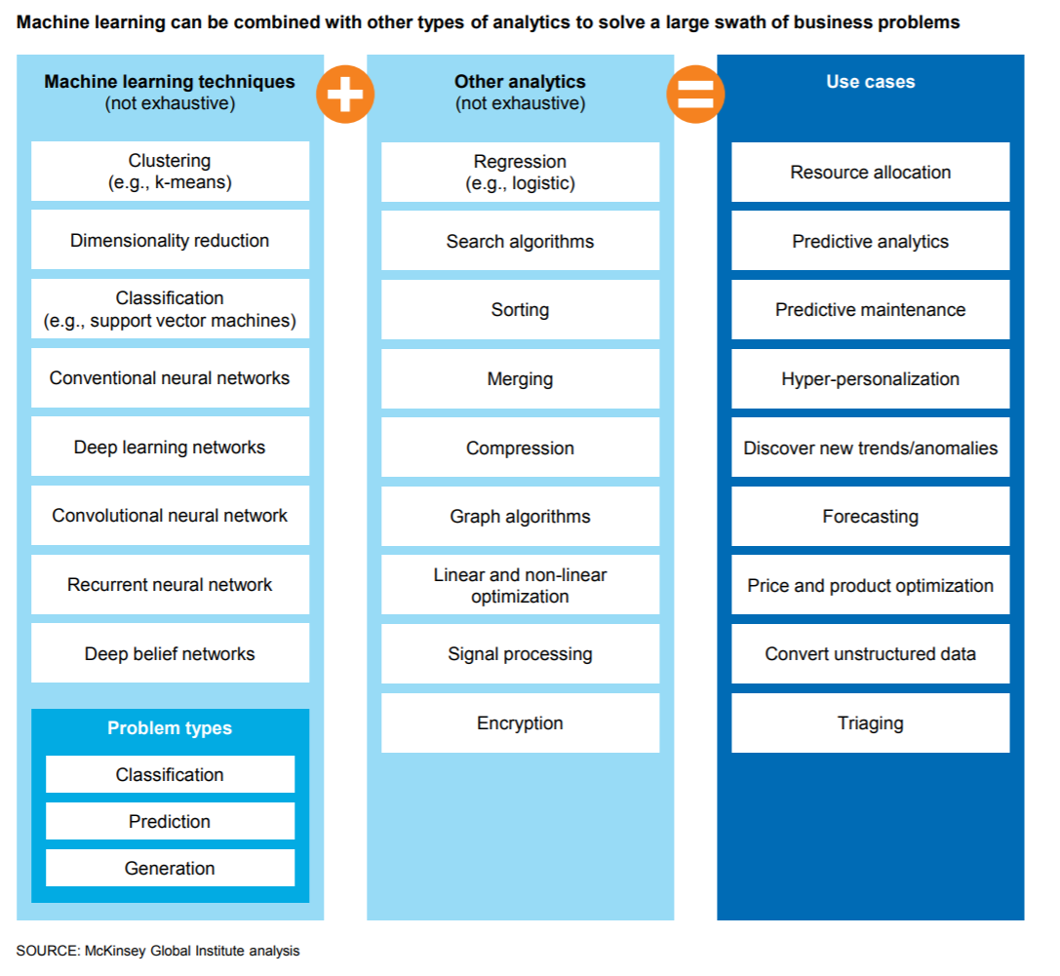

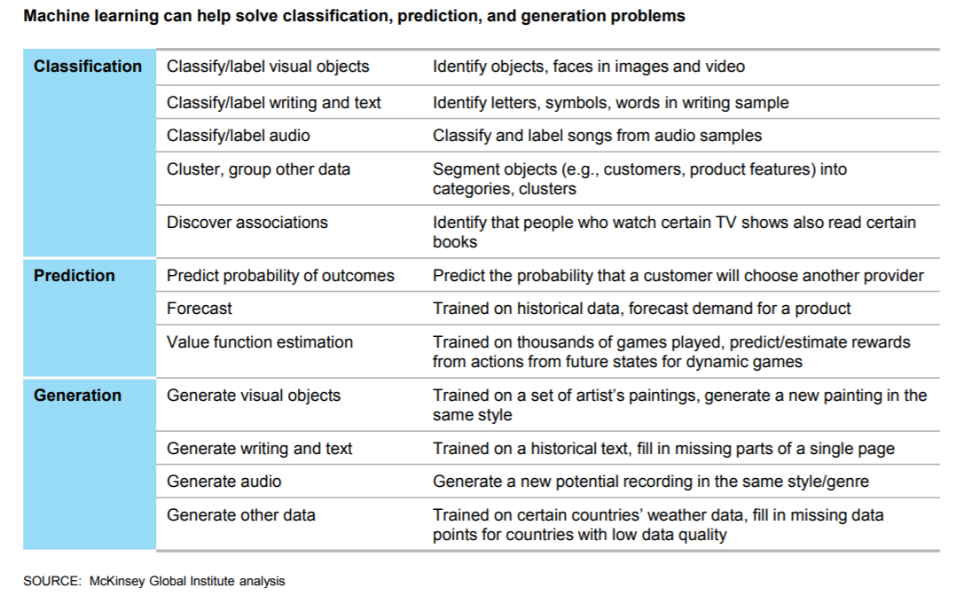

U.S. retailer supply chain operations who have adopted data and analytics have seen up to a 19% increase in operating margin over the last five years. Location-based services and U.S. retail are showing the greatest progress capturing value from data and analytics. Location-based services are capturing up to 60% of data and analytics value today predicted by McKinsey in their 2011 report. McKinsey predicts there are growing opportunities for businesses to use geospatial data to track assets, teams, and customers across dispersed locations to generate new insights and improve efficiency. U.S. Retail is capturing up to 40%, and Manufacturing, 30%. The following graphic compares the potential impact as predicted in McKinsey’s 2011 study with the value captured by segment today, including a definition of major barriers to adoption.

Design-to-value, supply chain management and after-sales support are three areas where analytics are making a financial contribution in manufacturing.

40% of all the potential value associated with the Internet of Things requires interoperability between IoT systems.

The EU public sector: McKinsey Global Institute McKinsey Analytics 2011 report analyzed how the European Union’s public sector could use data and analytics to make government services more efficient, reduce fraud and errors in transfer payments, and improve tax collection, potentially achieving some €250 billion worth of annual savings. But only about 10 to 20 percent of this has materialized. Some agencies have moved more interactions online, and many (particularly tax agencies) have introduced pre-filled forms. But across Europe and other advanced economies, adoption and capabilities vary greatly. The complexity of existing systems and the difficulty of attracting scarce analytics talent with public-sector salaries have slowed progress. Despite this, we see even wider potential today for societies to use analytics to make more evidence-based decisions in many aspects of government.

Machine learning’s greatest potential across industries includes improving forecasting and predictive analytics. McKinsey analyzed the 120 use cases their research found as most significant in machine learning and then weighted them based on respondents’ mention of each. The result is a heat map of machine learning’s greatest potential impact across industries and use case types

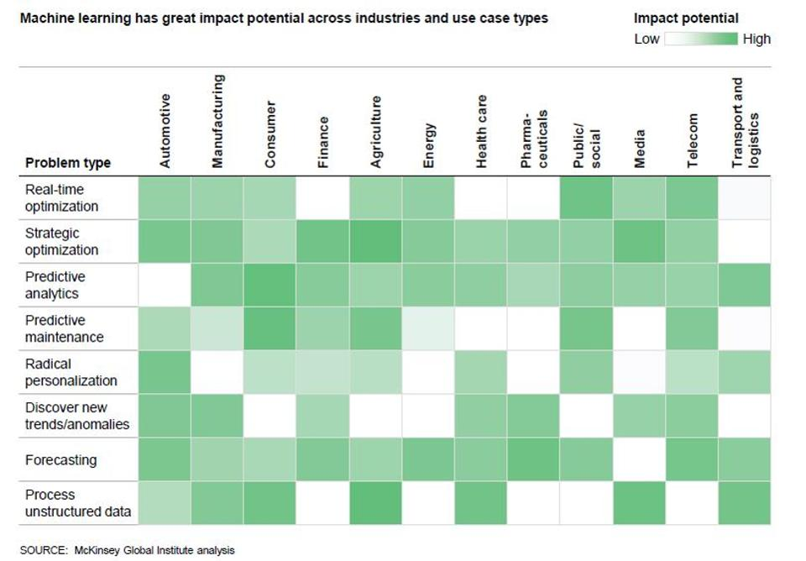

Machine learning's potential to deliver real-time optimization across industries is just starting to evolve and will quickly accelerate in the next three years. McKinsey analyzed the data richness associated with each of the 300 machine learning use cases, defining this attribute as a combination of data volume and variety. Please see page 105 of the study for a thorough explanation of McKinsey’s definition of data volume and variety used in the context of this study The result of evaluating machine learning’s data richness by industry is shown in the following heat map:

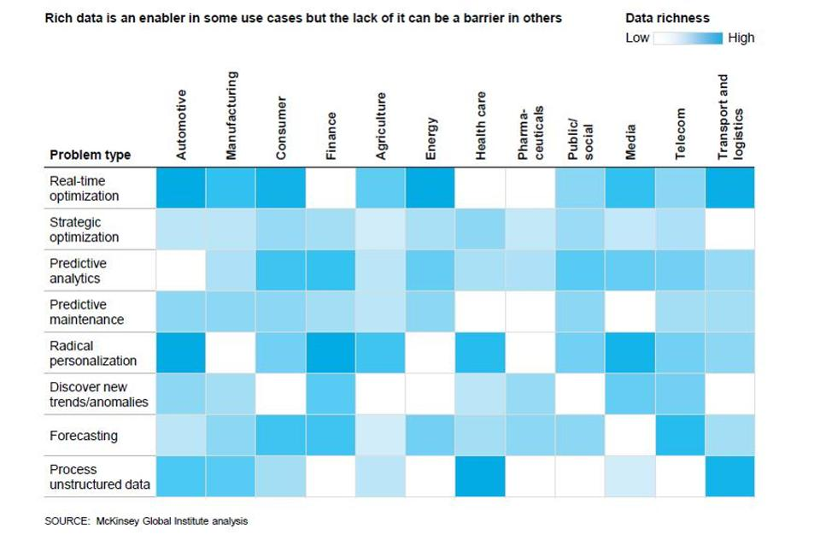

Enabling autonomous vehicles and personalizing advertising are two of the highest opportunity use cases for machine learning today. Additional use cases with high potential include optimizing pricing, routing, and scheduling based on real-time data in travel and logistics; predicting personalized health outcomes, and optimizing merchandising strategy in retail. McKinsey identified 120 potential use cases of machine learning in 12 industries and surveyed more than 600 industry experts on their potential impact. They found an extraordinary breadth of potential applications for machine learning. Each of the use cases was identified as being one of the top three in an industry by at least one expert in that industry. McKinsey plotted the top 120 use cases below, with the y-axis shows the volume of available data (encompassing its breadth and frequency), while the x-axis shows the potential impact, based on surveys of more than 600 industry experts. The size of the bubble reflects the diversity of the available data sources.

